1. First of all, I`m considering to remove the functionality “Add transaction” manually
2. **I get an error when uploading a transaction file:** “**strptime() argument 1 must be str, not Timestamp” (pls. see below screenshot). Pls. correct the code to correctly handles the type Timestamp**

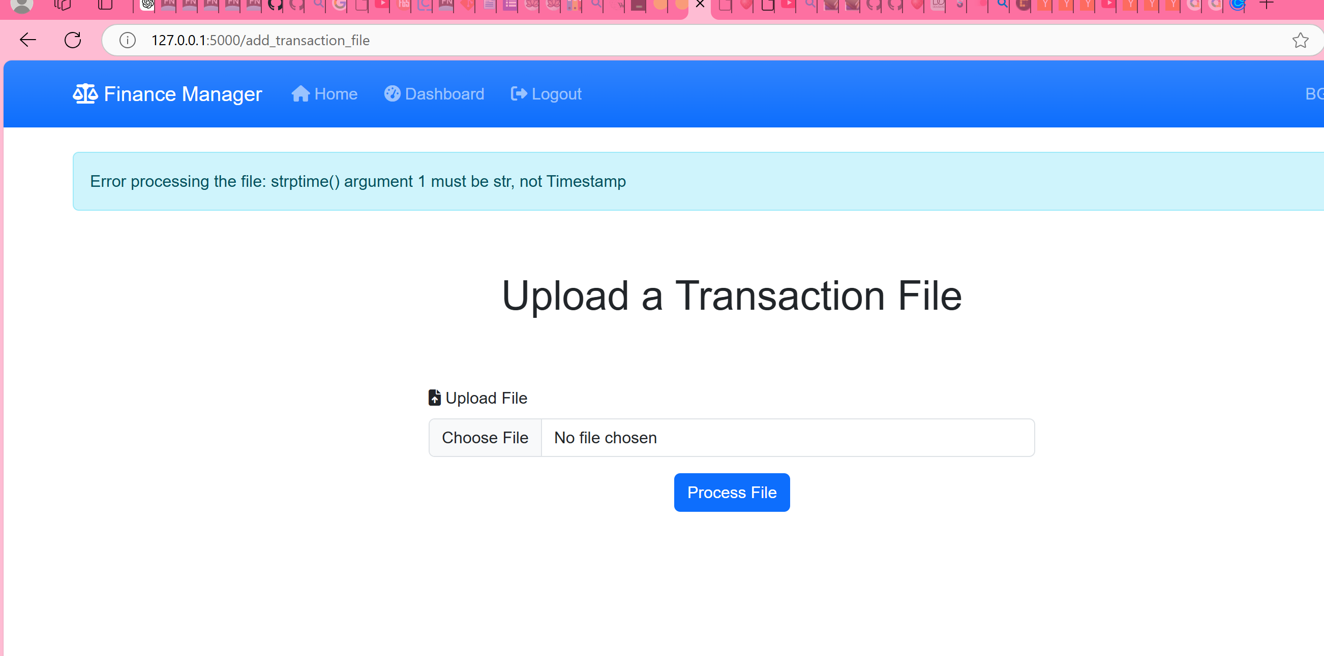

1. By deleting a transaction message is in BG, pls. correct it to EN: 'Transaction successfully deleted.'

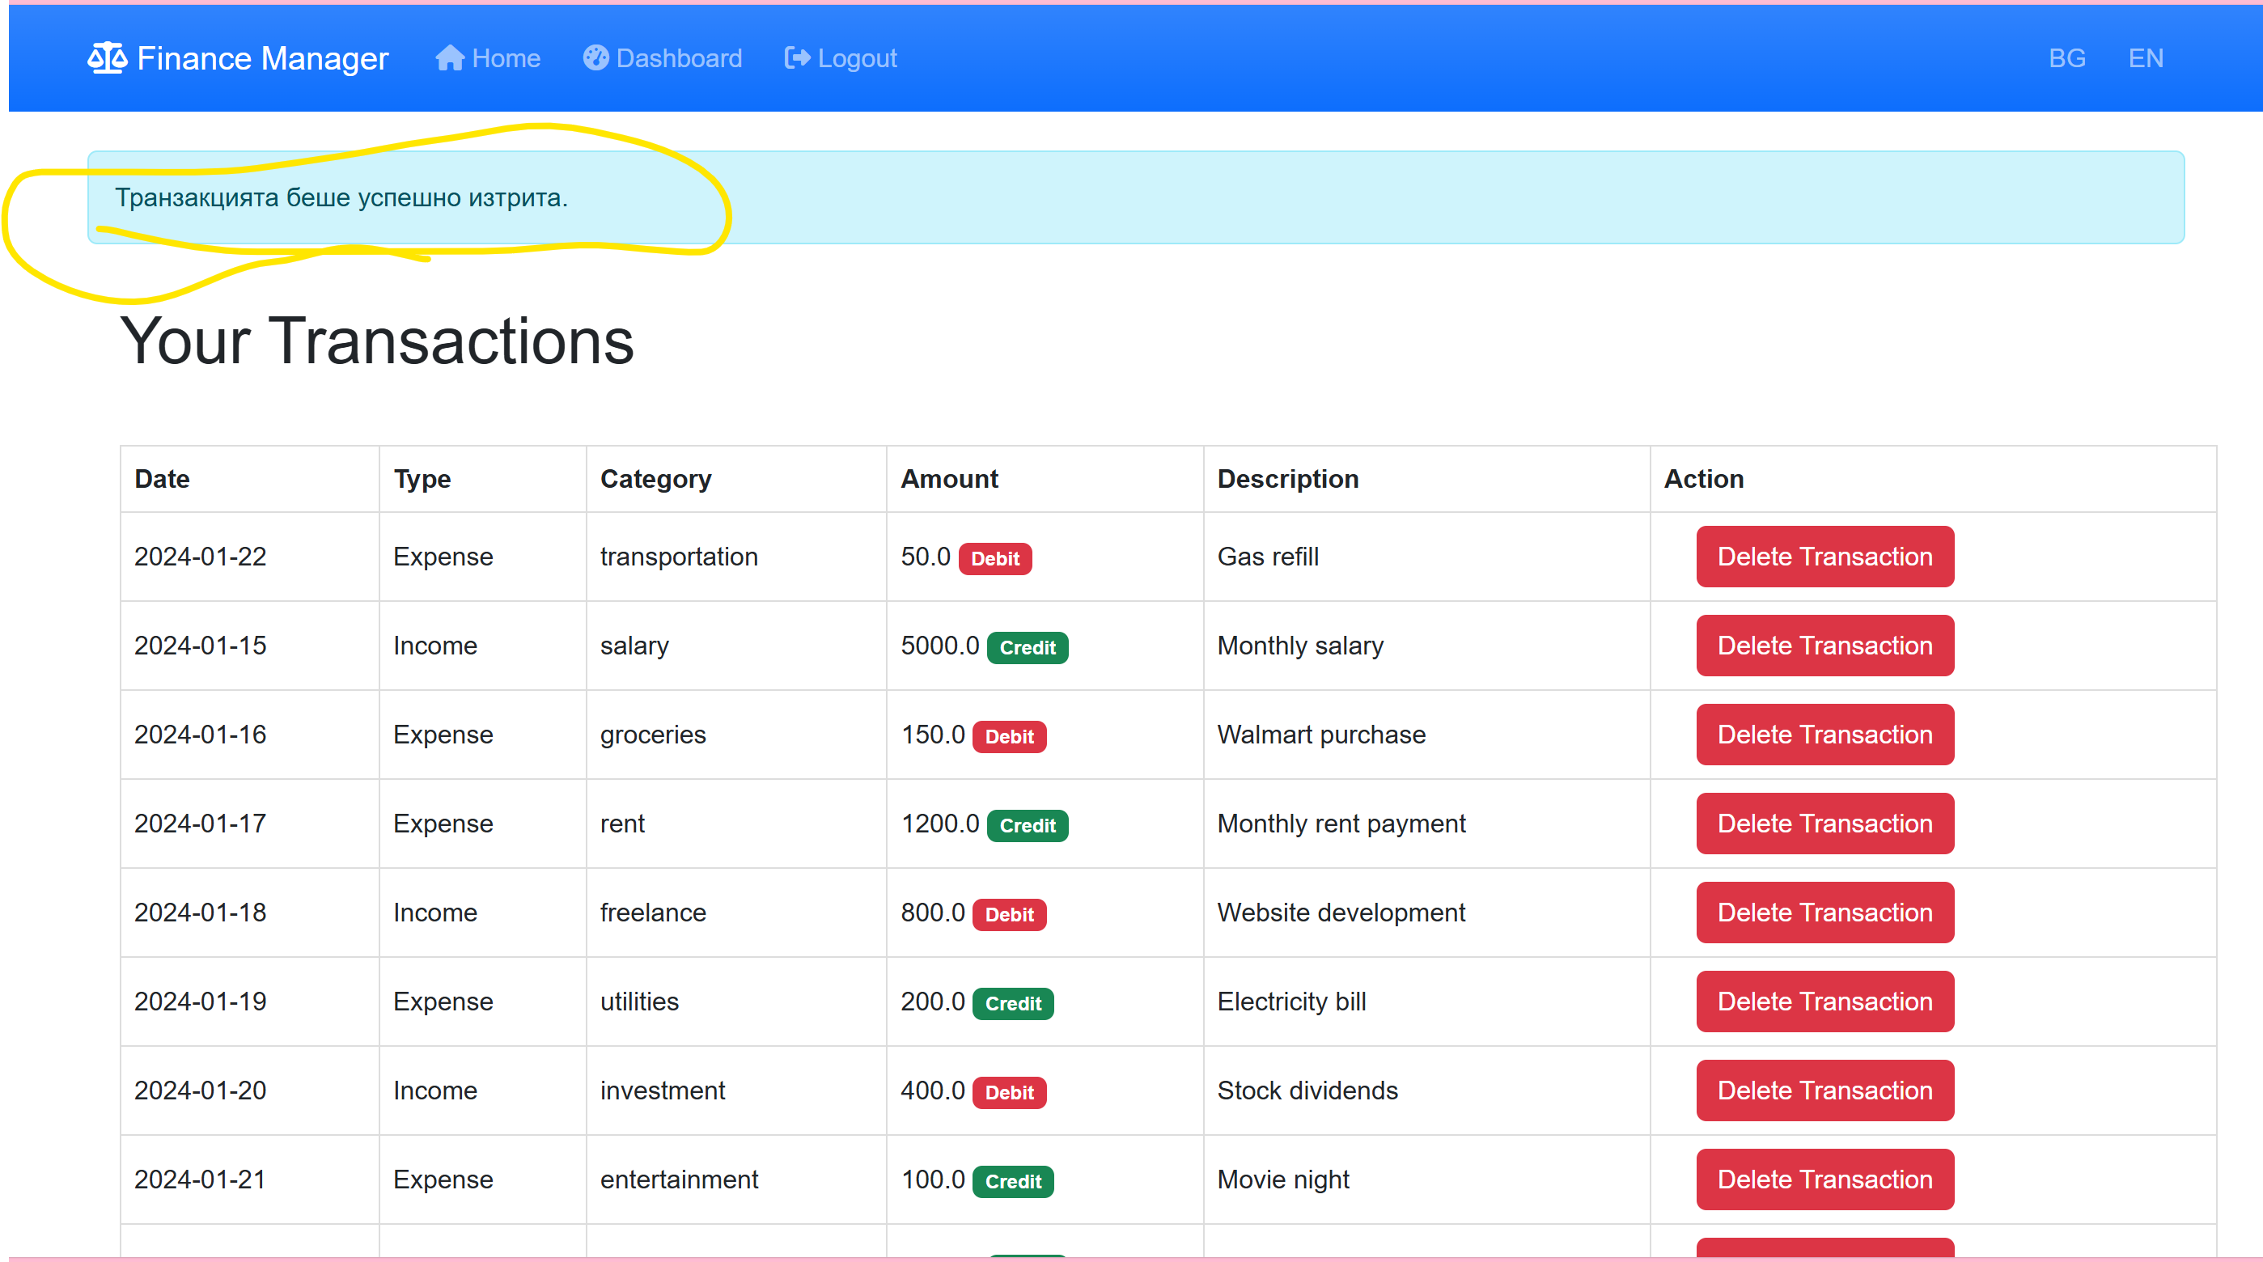

1. Balance Sheet doesn`t generate any amounts. Pls. correct.

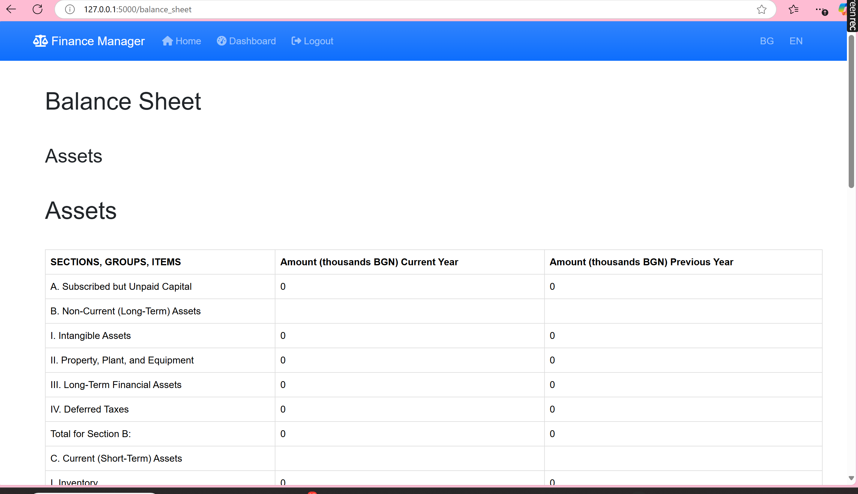

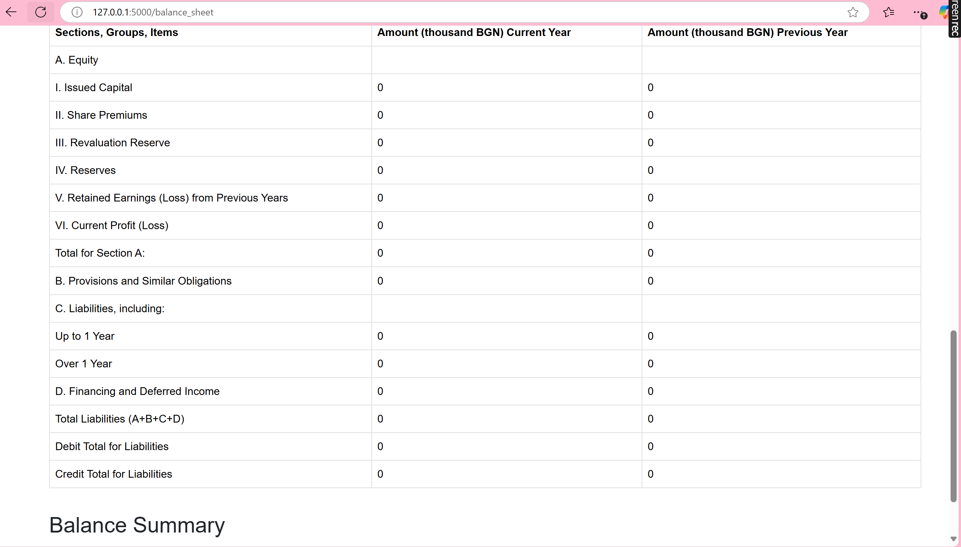

1. Income Statement generates amounts in BGN, they have to be in EUR, pls. correct in the code.

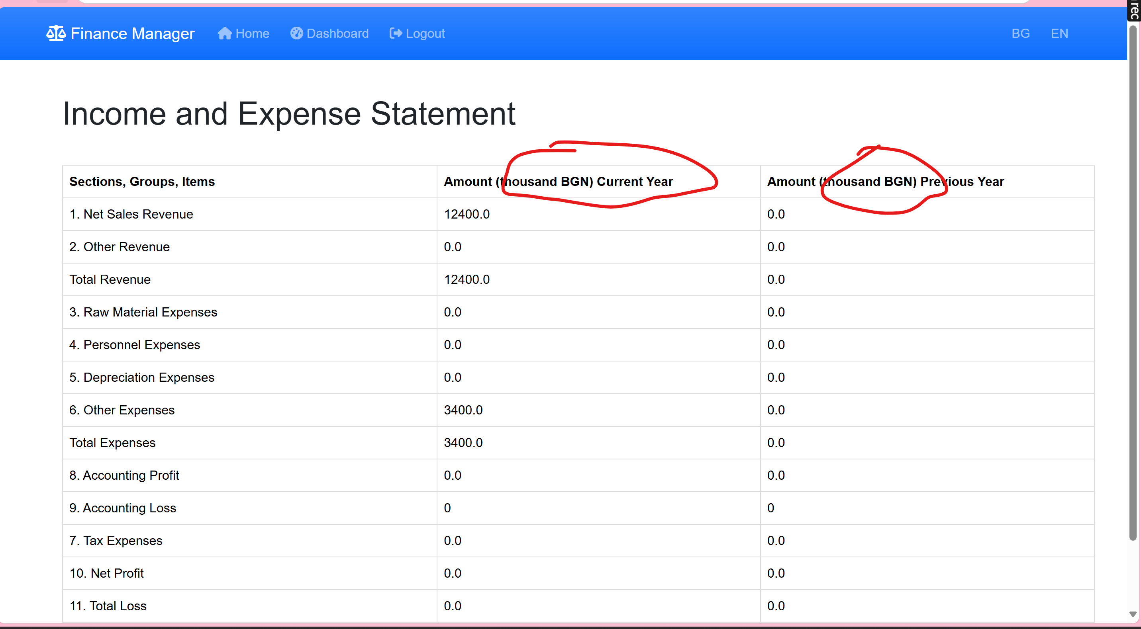

1. Download in Excel and Word is some kind of General Ledger, it has to be downloaded Balance Sheet and Income Statement with their forms, as they are with 3 columns (Sections, Groups, Items)/ Amounts current year/ Amounts previous year. Also, Balance sheet amounts are in BGN, they have to be in EUR. Pls., correct the forms of the Balance sheet and Income Statement and the name of the currency.

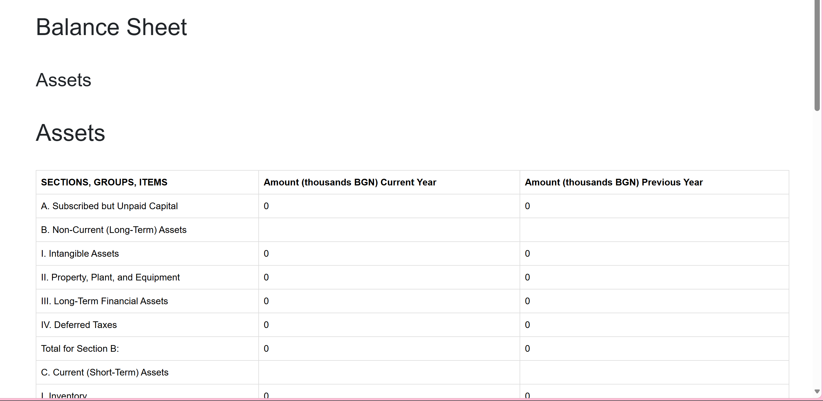

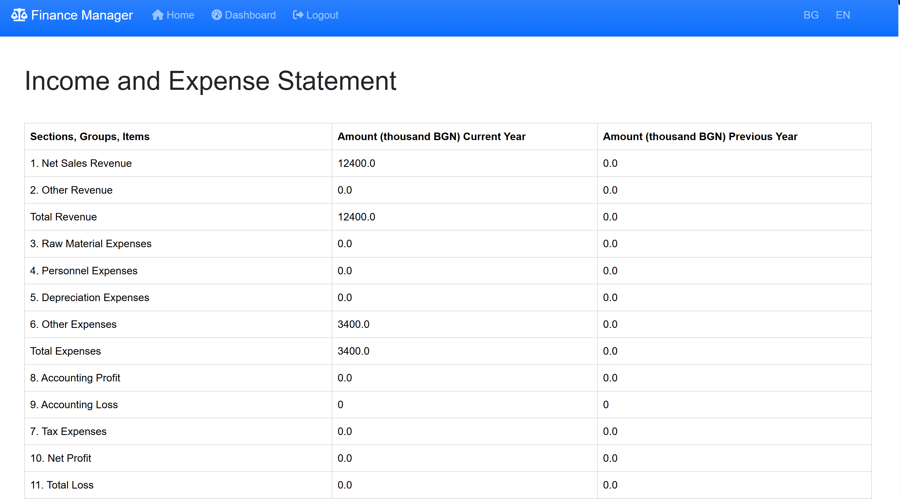

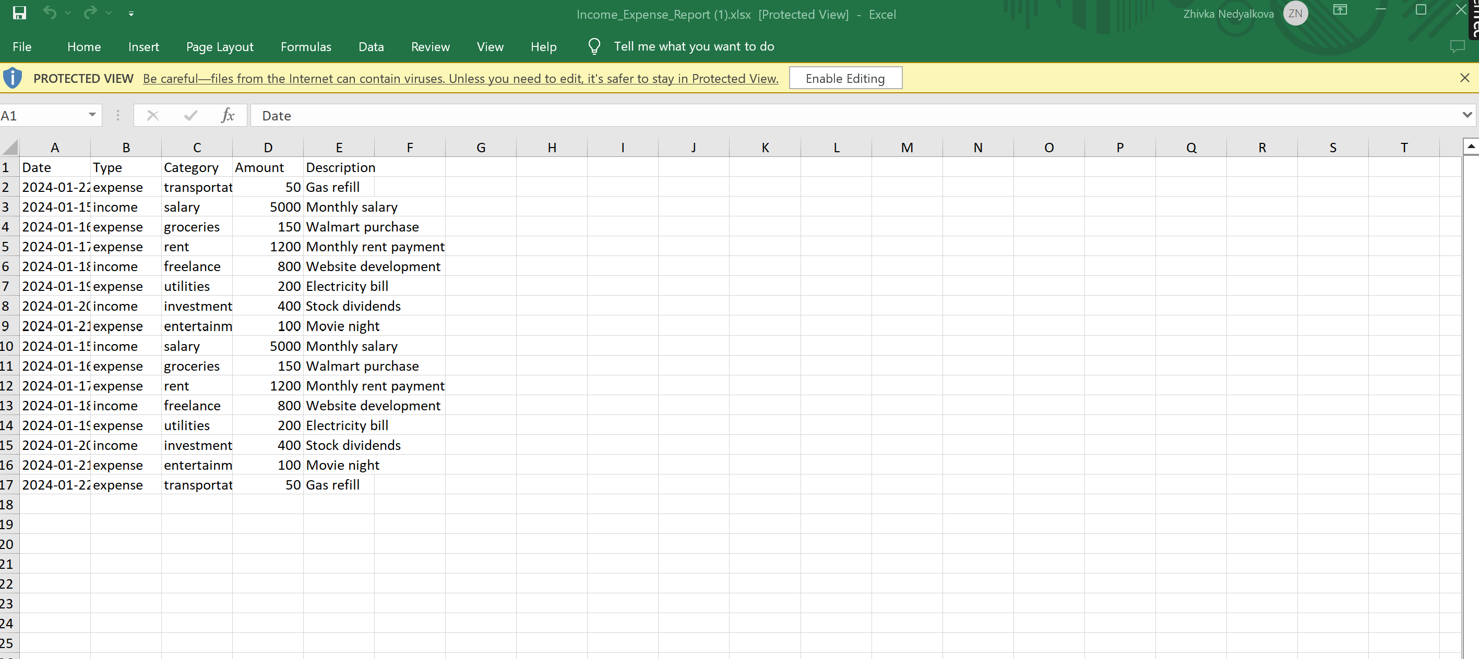

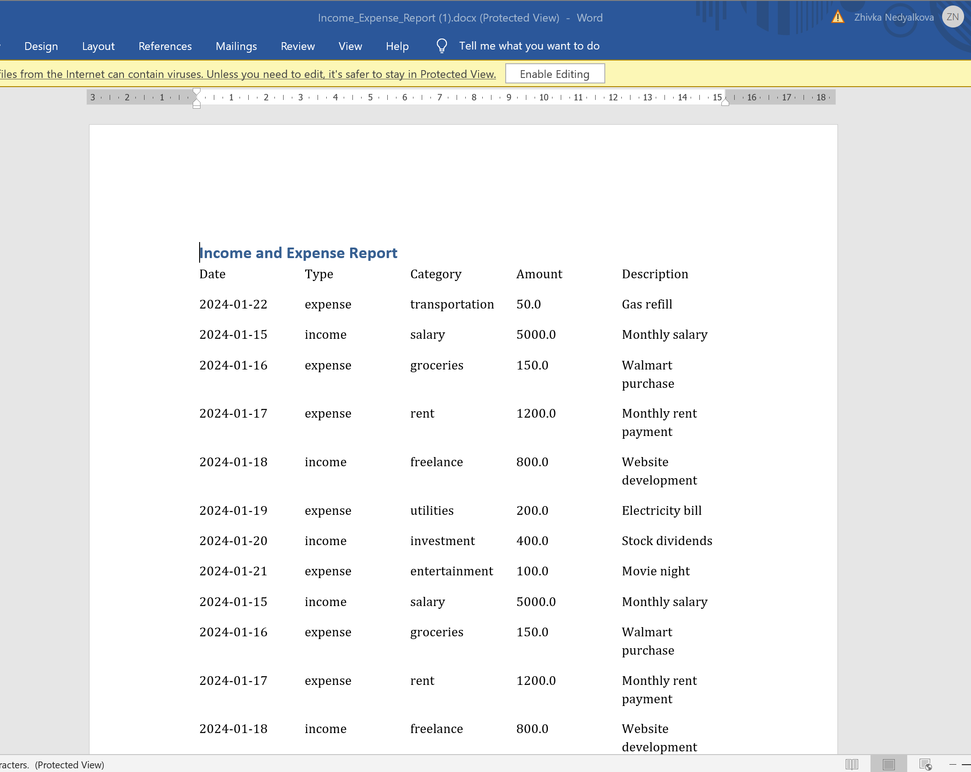

1. PDF format of the download function is generating the Expense visualization (see below). Pls. correct it- it has to be downloaded Balance sheet and Income statement in their forms as they are generated in the app.

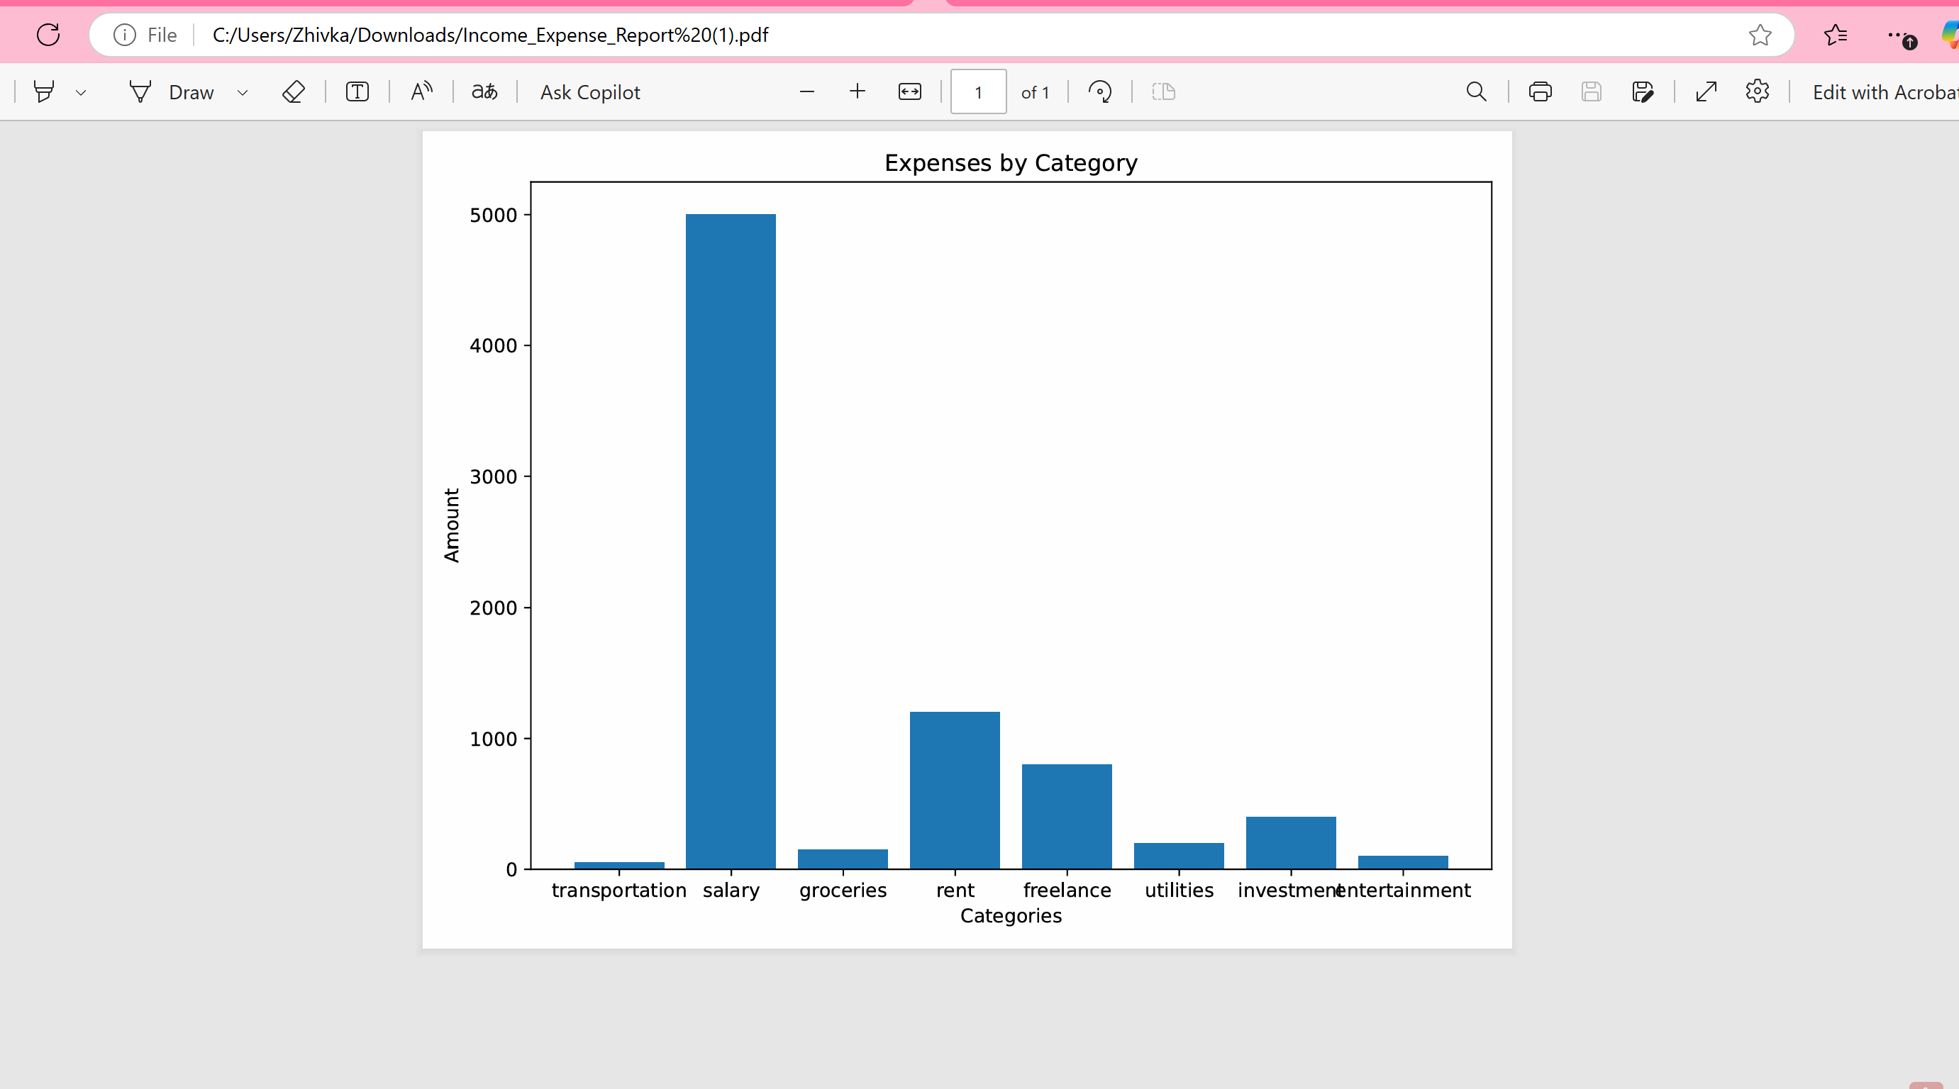

1. Currently both Home and Dashboard lead to the features screen, please adjust so that Home leads to features and Dashboard leads to reports directly, which are generated via View reports (pls. see below)

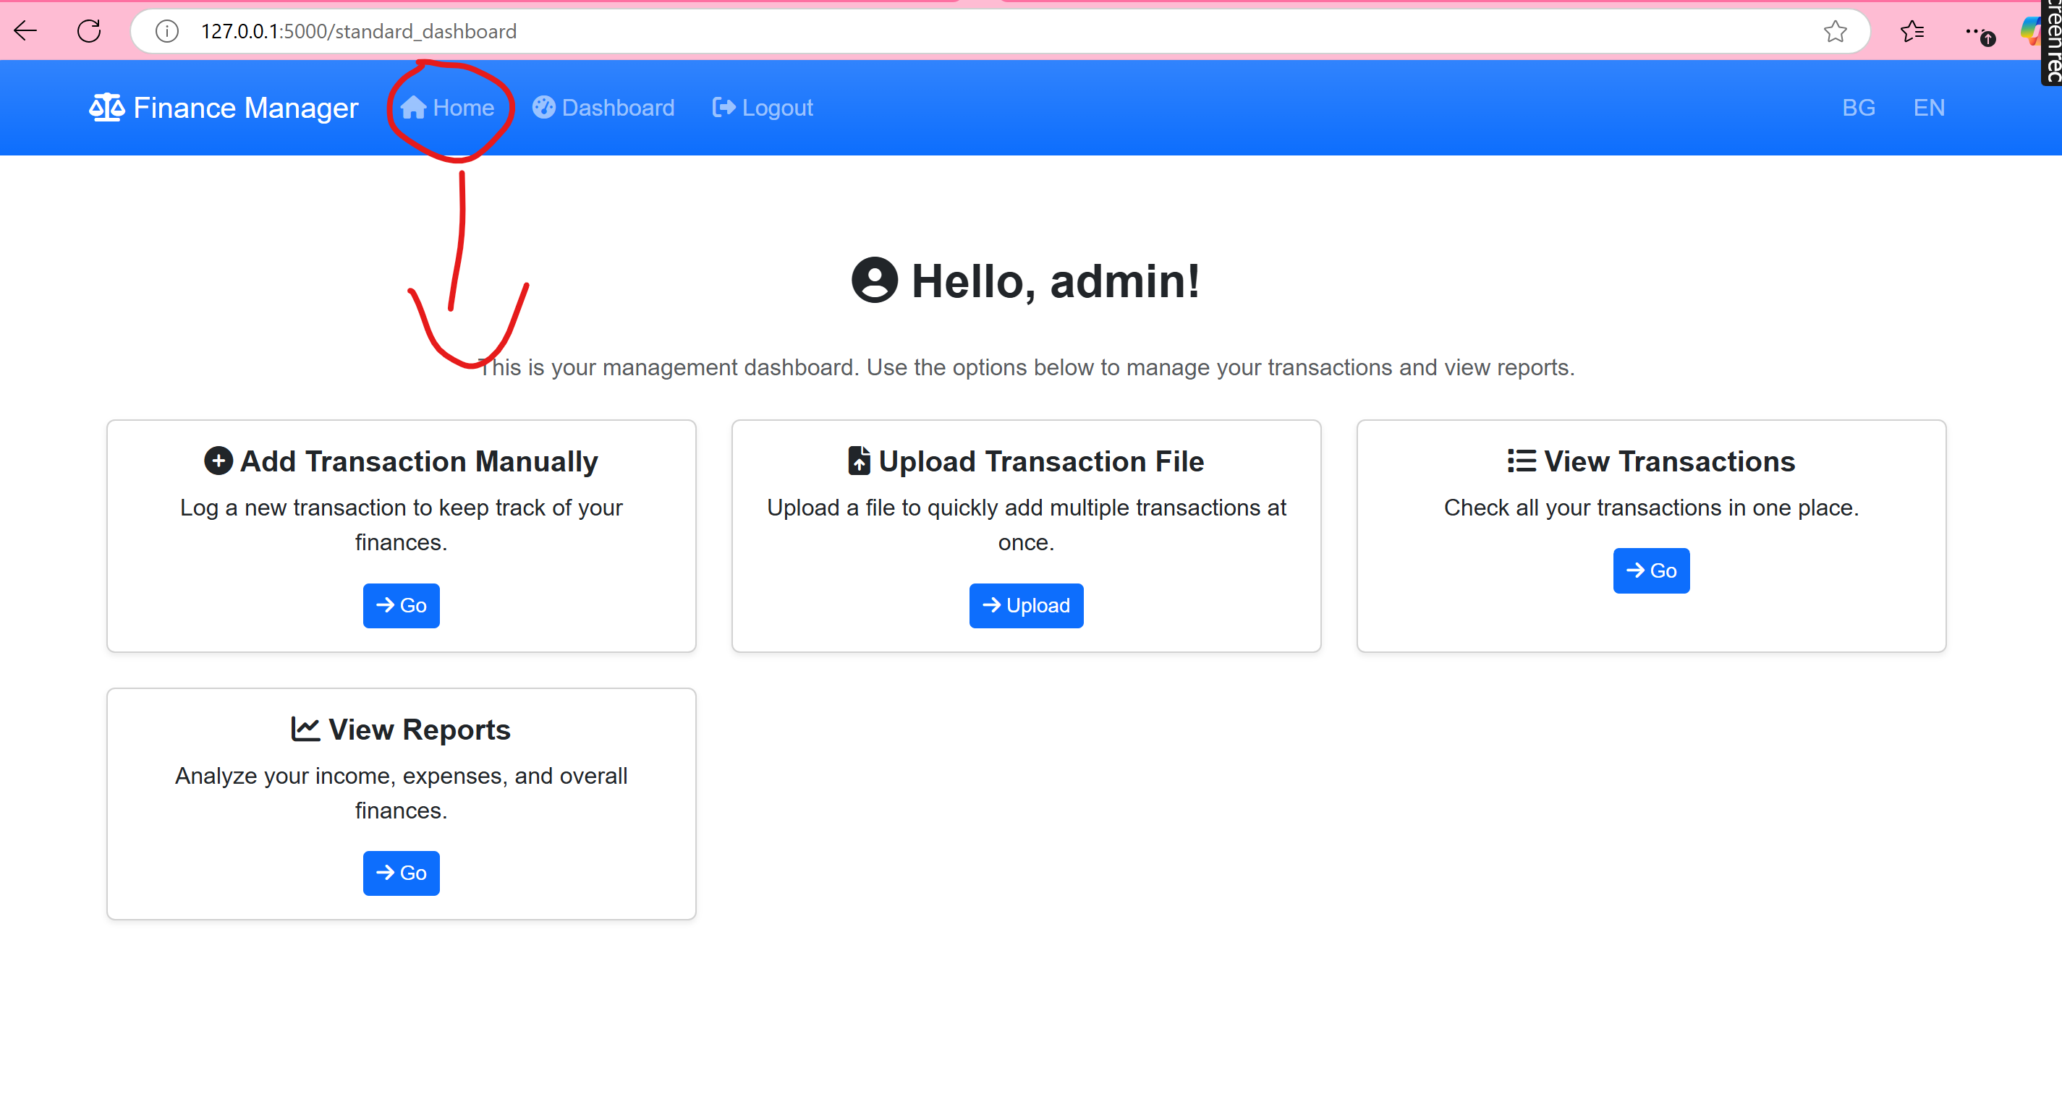

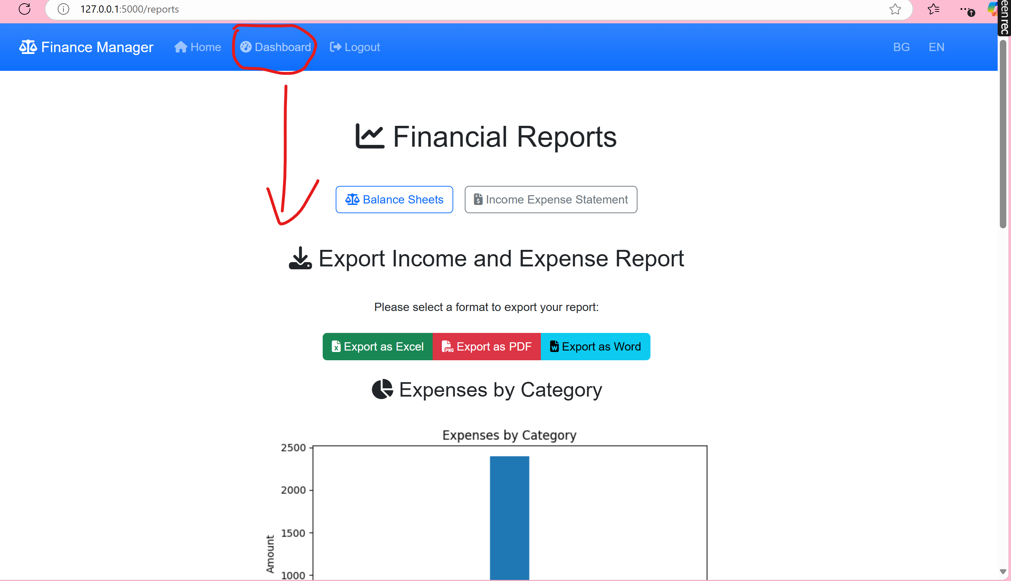

1. There is no General Ledger functionality at all. General Ledger functionality has to reflect all the recorded transactions with their debits and credits. It has to be something like that but with debit/ credit columns.

